**Mohnish Chandiramani**

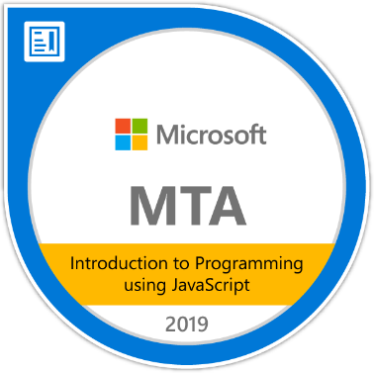

Rose Icon, A Wing, Flat no.407,

Pimple Saudagar, Pune-411027.

**Mobile:** 9158643812

**E-mail:** moni2685@gmail.com

**CAREER OBJECTIVE:**

To obtain a position that will allow me to utilize my technical skills and willingness to learn in making the organization successful.

**ACADEMIC QUALIFICATIONS:**

|  |  |  |  |  |
| --- | --- | --- | --- | --- |
| **Degree/**  **Certificate** | **Board/ University** | **School/College** | **Year of passing** | **Percentage/CGPA** |
| B.E Computer | SPPU,  Pune. | Pimpri Chinchwad Education Trust’s NMIET. | - | IV. 8.5  III. 7.5  II. 8.00  I. 7.88 |
| H.S.C | Maharashtra State Board. | Jai Hind Jr. College | 2015 | 77.08% |
| S.S.C | Maharashtra State Board. | Jai Hind High School | 2013 | 88.73% |

**TECHNICAL SKILLS:**

|  |  |  |
| --- | --- | --- |
| Database | Oracle, MySQL. | Intermediate |
| Tools | Git, Maven, Jenkins | Intermediate |
| Technologies | Java, Angular 8, Spring MVC, Java Persistence API, Servlets, HTML, CSS, Javascript, JPQL. | Intermediate |
| Technologies | Python, AJAX, RESTful Web Services, Bootstrap. | Beginner. |

**PROJECTS:**

|  |  |
| --- | --- |
| **3rd Year Project** | |
| **Project Name:** | All things College. |
| **Description:** | A simple android application designed for teachers to record the attendance of the students. |
| **Objective:** | To make the attendance procedure more convenient without the need of pen and paper. |

|  |  |
| --- | --- |
| **4th Year Project** | |
| **Project Name:** | Automatic Door unlock using facial recognition system. |
| **Description:** | A mechanism to unlock the door automatically for an authorized person. The facial data of the person is stored in the raspberry pi and that data is used to unlock the door automatically using Machine Learning. The approach used was Eigenvectors, Haar features and Eigenfaces. |
| **Objective:** | To make the Door unlocking system more secure and convenient. |

|  |  |
| --- | --- |
| **Project under Larsen & Toubro Infotech.** | |
| **Project Name:** | Women Empowerment. |
| **Description:** | The objective of the scheme is to promote availability of safe and conveniently located accommodation for working women, with day care facility for their children,wherever possible, in urban, semi urban, or even rural areas where employment opportunity for women exist. |
| **Objective:** | To automate certain government procedures that are otherwise manual and offline. |
| **Technologies used:** | Spring MVC, Java, Github, AJAX, Javascript, JSP, Jquery, Java Persistence API. |

|  |  |
| --- | --- |
| **Others.** | |
| **My website URL** | <https://moni2197.github.io/> |
| **My Angular News Website** | <https://my-news-application-23ca6.firebaseapp.com> |

**EXTRA/CO-CURRICULAR ACTIVITES:**

* Training on Internet of things technologies and Raspberry pi.
* Certification in Web Design using HTML, CSS, Bootstrap and PHP.
* Certification in Microsoft’s Cross Platform Mobile Application Development.
* Project leader for third year and final year projects.
* Took part as a volunteer in Training and Placement activities of the college.
* Secured State rank Of 111 in the International Olympiad of English Language.
* Won the Counter Strike Competition of College.

**HOBBIES:**

* Competitive Gaming: CS:GO, Fortnite.
* Exploring new technologies.